



**The Ridge Supporters**

**CHARITY PIG RACE NIGHT**

**Friday 10th October 2025**

**Forester’s Arms, Adwick, DN6 7AA**

**7.00pm (First Race 7.30pm)**

**Tickets:**

**With Pulled Pork Sandwich + Chips £10.00**

**Entry only £5.00**

**Free Prize Draw with Entry Ticket**

**All Bets £1.00**

**Raffle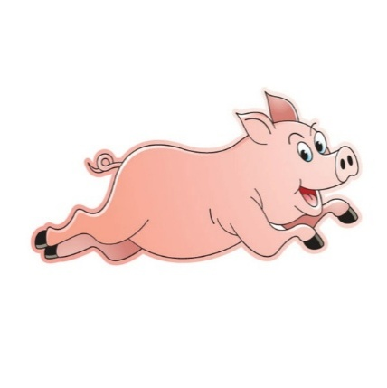 on the night - £1 per strip (lots of piggy prizes)**